Built by Harlan & Wolff Limited, Belfast, Northern Ireland, 1901. 20,904 gross tons; 700 (bp) feet long; 75 feet wide. Steam quadruple expansion engines, twin screw. Service speed 16 knots. 2,857 passengers (347 first class, 160 second class, 2,350 third class).Two funnels and four masts.
Built for White Star and Dominion Lines, in 1901 and named Celtic. Liverpool-New York service. Largest ship afloat 1901-03. Stranded in Cobh harbor and declared a total loss and Scrapped in 1928.
You can purchase this image and information by clicking "Add to Shopping Cart."
The Celtic
Associated Passenger | Date of Arrival | Port of Departure
Butler, Timothy | Jun 11, 1920 | Queenstown

  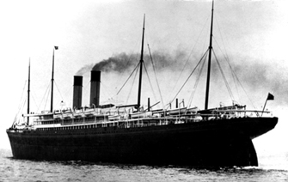
   | Purchase this item
   | Choose a size:
   |  5x7 | $10.00
   |  9x12 | $12.50
  Built by Harlan & Wolff Limited, Belfast, Northern Ireland, 1901. 20,904 gross tons; 700 (bp) feet long; 75 feet wide. Steam quadruple expansion engines, twin screw. Service speed 16 knots. 2,857 passengers (347 first class, 160 second class, 2,350 third class).Two funnels and four masts.
  Built for White Star and Dominion Lines, in 1901 and named Celtic. Liverpool-New York service. Largest ship afloat 1901-03. Stranded in Cobh harbor and declared a total loss and Scrapped in 1928.
 | Photo: Alex Duncan

